|  |
| --- |
| SKP Games |
| Jungle Explorer |
| **2D Jungle Platformer** |
| Version #01  All work Copyright © 2019 by SKP Games.  All rights reserved. |
| **John Kevin Yuayan** |
|  |

|  |
| --- |
| Nov 3rd 2019 |

**Table of Contents**

[Your Table of Contents should go here. Make sure that your document’s sections are hyperlinked to their corresponding pages.]

**Version History**

[This is where you keep track of the detailed changes made to your document throughout the course of development.]

[This is the body of your video game design document. You should add and delete sections as they pertain to your game’s design.]

1. **Game Overview**

You play as Pete, a pilot that seeks adventure. You just arrived in the mysterious forest in search of the 7 forbidden fruits. Collect all the fruits to win, but be careful of the undead skeletons that guard the rare fruit.

1. **Game Play Mechanics**

The player gains score by collecting fruits scattered across the level. Colliding with the skeleton enemies causes you to lose a life and start back at the beginning

1. **Camera**

The camera is a side scroller. The camera follows the player’s x coordinate, but maintains it’s own y coordinate.

1. **Controls**

WASD and arrow keys for movement.

Spacebar to jump

1. **Saving and Loading**

There is no saving or loading, the player has 5 lives to get all 7 fruits

1. **Interface Sketch**

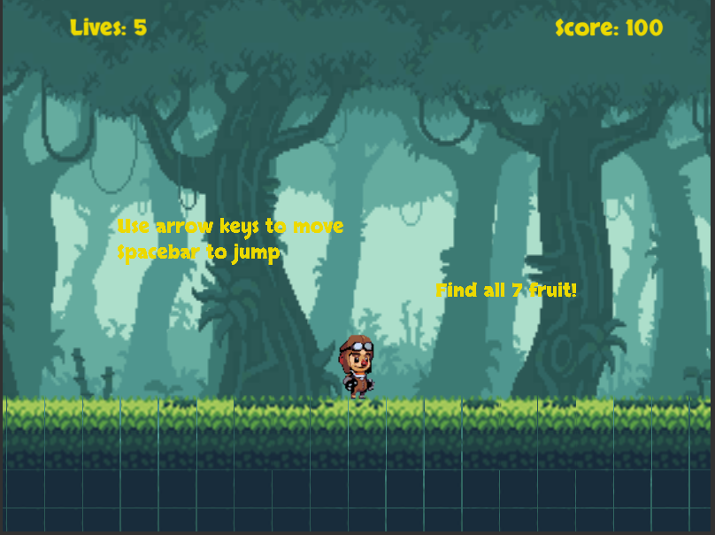

1. **Menu and Screen Descriptions**

**Main Screen**



**Game Over Screen**

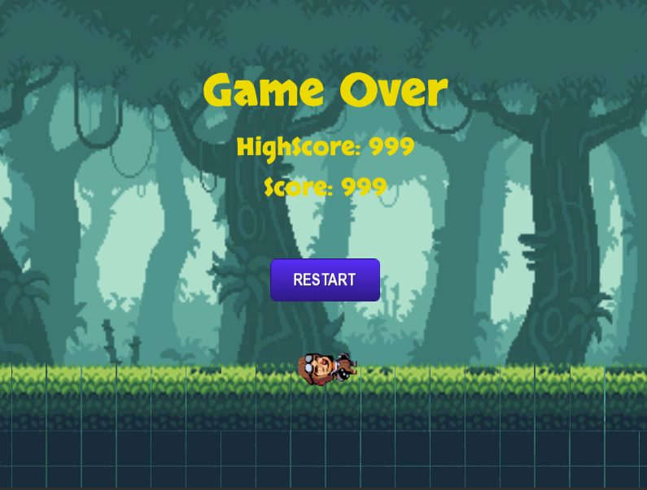

1. **Game World**

The game takes place in a mysterious forest with undead skeletons roaming about.

1. **Levels**

There is one level with different platforming challenges and 7 fruits to collect

1. **Game Progression**
2. **Characters**

The main character is Pete. He’s a pilot in search of adventure in the mysterious forest.

1. **Non-player Characters**
2. **Enemies**

Skeleton - Skeleton enemy that walks until it hits a wall or a there is no ground in front of it. At that point the skeleton turns around and continues walking.

1. **Weapons**

Player has no weapons. The player only has their jump to avoid dangers and collect the fruits.

1. **Items**

There are 7 fruits scattered for the player to find and collect.

1. **Abilities**

**N/A**

1. **Vehicles**

N/A

1. **Script**

**N/A**

1. **Scoring**

Scoring is based on the number of fruits the player collects. The player gains 100 points per fruit.

1. **Puzzles/Mini-games**

**N/A**

1. **Bonuses**

**N/A**

1. **Cheat Codes**

**N/A**

1. **Sound Index**

pickup sound- Collecting fruits

hit sound- When the player loses a life

jump sound- When the player jumps

BG_Music - Music during the Main Scene

1. **Story Index**

N/A

1. **Art / Multimedia Index**

Player has animations for idle, moving, and jumping

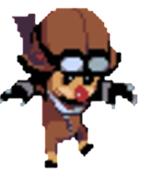

Skeleton has animations for moving

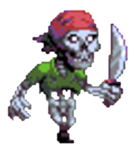

1. **Design Notes**

N/A

1. **Future Features**

Checkpoints

New Levels

Weapons

New enemies/Bosses